The Ahmadi Muslim Community

In the fall of 1992, members of the Ahmadiyya community in Toronto began to attend prayers at Bai’tul Islam, the largest specially designed mosque with a minaret in Canada, located north of Canada’s Wonderland. The mosque features two large prayer halls, and other facilities that make it the cultural and religious centre for the Ahmadiyya community.
​
Close to 40,000 Canadian Ahmadi Muslims live in Ontario. Ahmadiyyat is a missionary movement that was founded in 1889 by Hazrat Mirza Ghulma Ahmad of Qadian (1835–1908). He proclaimed himself to be the Messiah, in fulfilment of the prophecies found in the Bible, Mahdi, and Quran, and as foretold in the Holy Quran and sayings of Prophet Mohammed. The movement has a membership of more than 200 million followers around the world. Ahmadi Muslims are well established in Pakistan, India, Indonesia, Bangladesh, the Caribbean, East and West Africa, Europe, and North America.
​
The first Ahmadis in Canada came in the 1950s, but the majority arrived in the 1980s and 1990s, composed primarily of refugees from Pakistan. The centre for community activity is Bai’tul Islam. The Mission House, located on a 25-acre property in Maple, Ontario, holds published translations of the Holy Quran in 54 languages and selected verses in 118 languages. Affiliated with it are newspapers, women’s and youth groups, and sports teams, which hold various events.
​
Throughout the year the Ahmadiyya Movement and its different auxiliary organizations hold several events. One of the most significant events for Canadian Ahmadis is their Annual Gathering in the first week of July. 20,000 Ahmadis attend this three-day event from different parts of Canada, USA and other countries. The Annual Convention is occasionally attended by the Supreme Head of the Ahmadiyya Movement in Islam, His Holiness, Mirza Maskoor Ahmad Caliph IV. When His Holiness is present, the attendance at the Annual Convention is increased substantially.
​
Muslim Television Ahmadiyya International (MTA Int.) is a unique network which is owned and operated by the Ahmadiyya Muslim Community and is fully financed by its worldwide members. It is the first 24-hour Worldwide Muslim Television direct to home channel. Programs are produced by communities in over 150 countries.

Places to Go

- AHMADIYYA MUSLIM JAMA`AT CANADA, (Tel. 905-303-4000, 10610 Jane St, Maple). The national headquarters of the movement.
For restaurants and specialty stores, see the chapters on Pakistani and East Indian communities.

Religious Centres, Schools and Other Institutions
​
The Ahmadiyya movement in Islam has 30 “Namaz Centres” (prayer centres) and 4 large mosques in Greater Toronto.
​
BAI’TUL ISLAM MOSQUE, (Tel. 905-303-4000, 10610 Jane Street, Maple).
BAI’TUL AFIYAT MOSQUE, (Tel. 416-287-2756, 255 Old Kingston Rd, Scarborough).
BAI’TUL HAMD MOSQUE, (Tel. 905-206-1364, 1194 Matheson Blvd E, Mississauga).
MASJID MUBARAK, (Tel. 905-303-4000, 10545 Hurontario St, Brampton).

Holidays and Celebrations
​
- JUMA’T-UL-WIDA, last Friday of Muslim Holy Month Ramadhan.
- EIDUL FITR, at the end of Ramadhan, on 1st day of Shawal (according to Muslim Lunar Calendar).
- EIDUL ADHIYA, on 10th of Zil-Hajj.
- MUSLEH MAUOOD DAY, held on February 20, celebrates the prophecy about the second Caliph, Hadrat Mirza Bashirudin Mahmood Ahmad.
- SEERATUN NABI DAY is dedicated to discuss the life and teaching of the Prophet of Islam.
- KHILAFAT DAY, on May 27, is held to educate the public about the institution of Caliphate, (“Khilafat”) the supreme head of the Ahmadiyya Movement. A symposium with lectures is held on this day.
​
See Holidays and Celebrations in Glossary.
​
​
Media
​
- AHMADIYYA GAZETTE CANADA, (Tel. 905-303-4000, https://www.ahmadiyyagazettecanada.ca, 10610 Jane St., Maple). A national monthly magazine published in Urdu, English and French.
- MUSLIM TELEVISION AHMADIYYA, (Website: https://www.mta.tv/ca) provides faith-based, educational, and cultural programming for Canadian audiences, with live coverage of national events and community activities of the Ahmadiyya Muslim Community in Canada.
- MUSLIM TELEVISION AHMADIYYA INTERNATIONAL (MTA INT.), (E-mail: info@mta.tv, www.mta.tv), is a unique network which is owned and operated by the Ahmadiyya Muslims.
- VOICE OF ISLAM, (Tel. 416-531-9991, https://voiceofislam.ca), is a weekly Urdu-language radio broadcast on FM 100.7 Toronto that aims to educate listeners about Islam and Ahmadiyyat. The show airs Sundays from 9 to 11 pm and is also accessible online via live streaming.

Organizations
​
- AHMADIYYA MOVEMENT IN ISLAM (AHMADIYYA MUSLIM JAMA`AT), CANADA, (Tel. 905-303-4000, www.ahmadiyya.ca, 10610 Jane St, Maple). President and Missionary in Charge: Lal Khan Malik. At the same address: Khuddam ul Ahmadiyya (youth wing), Ansarullah (senior wing), Lajna Amaullah (women’s wing), Nasi’rat ul Ahmdiyya (young ladies’ wing), and Atfalul Ahmadiyya (children under 16 wing).
​
​
Prominent Torontonians
​
Lal Khan Malik, President of the Ahamdiyya Community; Khalifa Abdul Aziz, lawyer; Hasanat Ahmad Syed, President, Human Rights Race Relations Centre; Abdul Aziz Khalifa, Vice President of Ahmadiyya Community in Canada; Mubarak Ahmad Nazir, Vice President of Ahmadiyya Community in Canada; Kaleem Ahmad Malik, Vice President of Ahmadiyya Community in Canada.
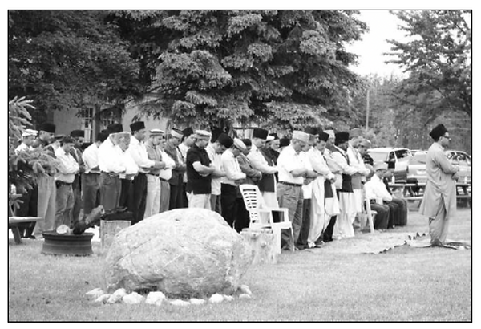
Community members at prayer on the eve of Ramadan (the Muslim holy month)

