The Albanian Community

Among the first Albanians to settle in Toronto was a businessman, Mr. Shamata, who arrived around 1902. He owned and operated his shoe store on Bloor Street West for more than 50 years.
​
Albanians, known as “Shqipetare” (Sons of the Eagle), are direct descendants of the Illyrians, the oldest inhabitants of Southeastern Europe. The first wave of Albanians to arrive in Canada arrived between 1904 and 1906. They settled in the greater Toronto area, working in factories and restaurants. Early cultural activities centred around konaks (boarding houses), religious organizations, and nationalist clubs. The second wave of immigrants came to Canada after the First World War. Among the new settlers was Sejdali Qerim, a prominent businessman who helped found the first mosque in Toronto.
​
Following the Second World War, many families immigrated to Canada from Albania, some settling in Ontario. Others entered Canada from countries such as Greece, Yugoslavia, Italy, and Turkey. The early 1990s saw another wave of Albanians immigrating to Canada, many settling in Toronto. Many of these recent settlers include professionals such as engineers, doctors, teachers, and accountants.
​
Toronto’s Albanian community currently numbers around 20,000. There are several Albanian organizations in the Toronto area, including: the Albanian Canadian Community Association (ACCA), and the Albanian Canadian Excellence Society (ACE), which promotes cultural heritage, community engagement, and professional development among Albanian Canadians.
​
​
Albanian emigrants in Canada after the Cold War

Most of the Albanians who live in Toronto came after 1990 when Albania opened its doors at the end of the Cold War and the collapse of Yugoslavia. The first Albanians who arrived in Canada after the Communist era of Eastern Europe were those who claimed refugee status. Obviously Canada hosted a number of Albanian emigrants as permanent residents as well. According to Canadian immigration consulting firms approximately another 1,000 Albanians came to Canada after immigration increased dramatically due to the economic crisis in Albania in 1997 and the 1998 conflict in Kosova. Around 1,000 Albanians came to Canada every year after 1997 and around 7,000 Albanians from Kosova arrived after 1998. There are no very well defined statistics, but there are around 25,000 Albanians in Canada and among them 14,000 are from their home country, 7,000 from Kosova and 4,000 from Macedonia. Almost 90 percent of the Albanian Community in Canada lives in the GTA and surrounding areas.
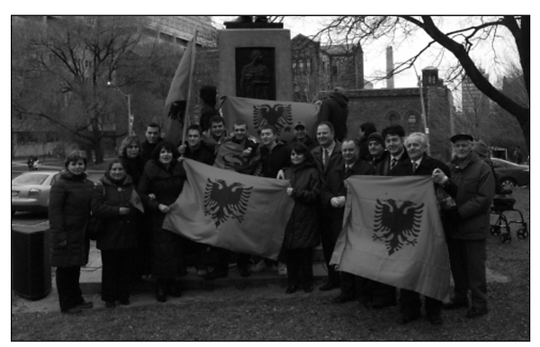
The Albanian community on Flag Day, exhibiting their pride in their national symbol—the double headed eagle.

​
Places to Go

Albanian-owned delicatessens in the city include: The Cheese Boutique, (Tel. 416-762-6292, 45 Ripley Ave.), College Fallafel, (Tel. 416-532-8698, 450 Ossington Ave.).
​
​
Religious Centres, Schools and Other Institutions

- The majority of Albanian-Canadians are Sunni (Orthodox) Muslims, or belong to the Bektashi sectarians. Most of the rest are Christians who belong to the Orthodox or Roman Catholic churches.
ALBANIAN MUSLIM SOCIETY, (Website: https://albmuslim.ca, 564 Annette St) is a mosque established in 1957 by Albanian immigrants.

Holidays and Celebrations
​
- INDEPENDENCE DAY is celebrated on November 28, in honour of the day in 1912 that Albania proclaimed its independence from the Ottoman Empire. The community celebrates with a program of speeches and cultural performances.
- KOSOVA’S INDEPENDENCE DAY, celebrates the July 2, 1990, declation by the Parliament of Kosova of an independent republic, equal to the other republics of the Yugoslav Federation. The Albanian Community celebrates on the second day of July with a program of speeches and cultural performances.
- SEPTEMBER 7 is the day the community celebrates the adoption of Kosova’s new constitution on September 7, 1990.
- ALBANIA NATIONAL INDEPENDANCE DAY (FLAG DAY), is celebrated on November 28, in honour of day in 1912 when Albania proclaimed its independant from the Ottoman Empire. The community celebrates it with the Albanian flag being raised in front of the Ontario Legislative Building (started 2009), speeches, cultural performance and banquets organized all over the province.

Organizations
​
- ALBANIAN CANADIAN COMMUNITY ASSOCIATION (ACCA), (info@albcan.ca, 85 Ingram Drive). President: Irene Breznica.
- ALBANIAN CANADIAN EXCELLENCE SOCIETY - ACE, (Tel.__________________, https://www.acesociety.ca, Adress_________________) is a non-profit organization composed of Albanian Canadian professionals. It focuses on building a strong professional community by encouraging networking, mentoring, and skill development. Chair of the Board: Ilda Fida
- ALBANIAN CANADIAN BUSINESS NETWORK -

Prominent Torontonians
Stephanie Teuta Haxhillari, realtor; Jani Papadhimitri, composer; Anton Brunga, Brunga Law Offices; Neritan Ciraku, Ciraku Law Offices; Meri Verli, Vice-President of Financing and Corporate Control, Lake Shore Gold Corporation; Agako Nouch, Vice-President of Ingersoll Rand Canada; Dr. Adriana Peci, respiratory epidemiologist at Ontario Agency for Health Protection and Promotion; Ferzi Bekiri, businessman; Kristaq Turtulli, writer; Ilir Lena, TV producer.
​
Contributors: Frank Bekirovski, President, Albanian Canadian Association of Toronto; Agim Hadri, President, Kosova Community and Information Centre.
​
Source: Aferdita Beqiri.

